Dear peers & instructor,

What is a class and an object?

A class is a collection of variables and methods that can be used to derive objects with varying values for the variables or allow other objects functionality related to the scope of the function of the class (Eck, 2019, p. 202). An object is an instance of a class which contains variables and methods that are assigned to it by the class while initiated. The class can also be analogized as a blueprint and the object as an object created from the blueprint. Thus consisting of the structure and behavior of the class or blueprint.

How do they relate?

An excellent explanation of the relation between classes and objects is said by Eck (2019, p. 235), “A class represents a set of objects that share the same structure and behavior. The class determines the structure of objects by specifying variables that are contained in each instance of the class, and it determines behavior by providing the instance methods that express the behavior of the objects.”

Example of a class can be seen below.

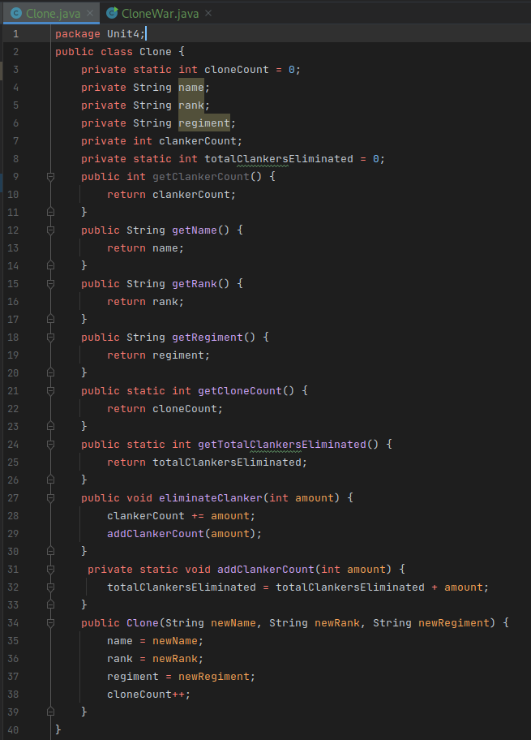

The class contains variables that are not accessible outside of class itself and thus has getter methods to return the value of the variables to wherever they are called from. Additionally, the class contains methods for functionality as well. The class represents variables and methods for creating clone troopers. The class contains static variables to keep track of the amount of clones created and the amount of droids eliminated (referred to as “clankers”) and a method to add to the amount droids eliminated. When an object or instance of the class is created, it consists of variables that hold the clone’s name, rank, and regiment. Additionally the object contains a method that eliminates a droid.

Below is an example of an instance of the class.

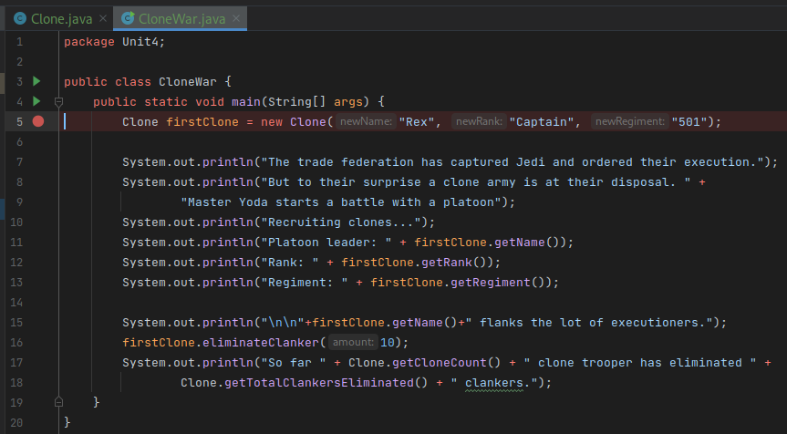

In this example, a clone is created by referring to a variable as the class type and adding new with the constructor method and its parameters to construct it. Then a series of events happen and the clone’s details are presented to the user followed by a call of the method to eliminate a droid. Finally, the class’s getter methods are called to obtain values that are only available in the class and not the object.

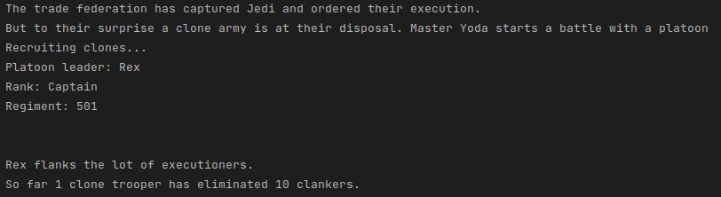

So, in conclusion is that class represents the structure and behavior of objects, additionally, the also contain variables and behavior that its objects might not necessary inherit.

References

Eck, D. J. (2019). Introduction to programming using Java, version 8.1.<http://math.hws.edu/javanotes>